 JMGG020V04A
m

Description

JMG N-channel Advanced Mode Power MOSFET
Features  40V,140A  RDS(ON)<2.2mΩ @ VGS = 10V  RDS(ON)<3.1mΩ @ VGS = 4.5V  Advanced Split Gate Trench Technology  Excellent RDS(ON) and Low Gate Charge  Lead free product is acquired | Application  Load Switch  PWM Application  Power management
 | 100% UIS TESTED! 100% ΔVds TESTED!
Schematic Diagram
PDFN5X6-8L

Marking and pin Assignment

Package Marking and Ordering Information

Device Marking | Device | OUTLINE | Device Package | Reel Size | Reel (PCS) | Per Carton  (PCS)
G020V04A | JMGG020V04A | TAPING | PDFN5X6-8L | 13inch | 5000 | 80000

Absolute Maximum Ratings (TC=25℃ unless otherwise specified)

Symbol | Parameter |  | Max. | Units
VDSS | Drain-Source Voltage |  | 40 | V
VGSS | Gate-Source Voltage |  | ±20 | V
ID | Continuous Drain Current | TC = 25℃ | 140 | A
 |  | TC = 100℃ | 91 | A
IDM | Pulsed Drain Current note1 |  | 560 | A
EAS | Single Pulsed Avalanche Energy note2 |  | 125 | J
PD | Power Dissipation | TC = 25℃ | 73 | W
RθJC | Thermal Resistance, Junction to Case |  | 1.7 | ℃/W
TJ , TSTG | Operating and Storage Temperature Range |  | -55 to +150 | ℃

JieJie Microelectronics CO. , Ltd Version :1.0
- 1 -

JMGG020V04A
μ
n
m
p
p
p
n
n
n
n

Electrical Characteristics (TJ=25℃ unless otherwise specified)

Symbol | Parameter | Test Condition | Min. | Typ. | Max. | Units
Off Characteristic
V(BR)DSS | Drain-Source Breakdown Voltage | VGS=0V, ID=250μA | 40 | - | - | V
IDSS | Zero Gate Voltage Drain Current | VDS=40V, VGS=0V, | - | - | 1.0 | A
IGSS | Gate to Body Leakage Current | VDS=0V, VGS= ±20V | - | - | ±100 | A
On Characteristics
VGS(th) | Gate Threshold Voltage | VDS=VGS , ID=250μA | 1.0 | - | 2.5 | V
RDS(on) | Static Drain-Source on-Resistance note3 | VGS=10V, ID=30A | - | 1.7 | 2.2 | Ω
 |  | VGS=4.5V, ID=20A | - | 2.2 | 3.1
Dynamic Characteristics
Ciss | Input Capacitance | VDS=20V, VGS=0V,  f=1.0MHz | - | 3162 | - | F
Coss | Output Capacitance |  | - | 1099 | - | F
Crss | Reverse Transfer Capacitance |  | - | 157 | - | F
Qg | Total Gate Charge | VDS=20V, ID=75A,  VGS=10V | - | 95 | - | C
Qgs | Gate-Source Charge |  | - | 15 | - | C
Qgd | Gate-Drain(“Miller”) Charge |  | - | 11 | - | C
Switching Characteristics
td(on) | Turn-on Delay Time | V DD=20V, ID=75A, RG=1.6Ω , VGS=10V | - | 12.5 | - | ns
tr | Turn-on Rise Time |  | - | 7 | - | ns
td(off) | Turn-off Delay Time |  | - | 50 | - | ns
tf | Turn-off Fall Time |  | - | 8.5 | - | ns
Drain-Source Diode Characteristics and Maximum Ratings
IS | Maximum Continuous Drain to Source Diode Forward Current |  | - | - | 140 | A
ISM | Maximum Pulsed Drain to Source Diode Forward Current |  | - | - | 560 | A
VSD | Drain to Source Diode Forward Voltage | VGS=0V, IS=30A | - | - | 1.2 | V
trr | Body Diode Reverse Recovery Time | TJ=25℃ ,  IF=IS ,dI/dt=100A/μs | - | 31 | - | ns
Qrr | Body Diode Reverse Recovery Charge |  | - | 110 | - | C
Notes:1. Repetitive Rating: Pulse Width Limited by Maximum Junction Temperature
2. EAS condition: TJ=25℃, VDD=20V, VG=10V, RG=25Ω , L=0.5mH, IAS=22.4A
3. Pulse Test: Pulse Width≤300μs, Duty Cycle≤0.5%

JieJie Microelectronics CO. , Ltd Version :1.0
- 2 -

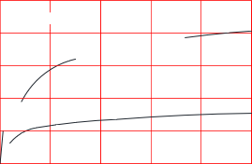

VDS=20V ID=75A
Qg(nC)

Figure 5: Gate Charge Characteristics VGS(V)
10

8

6

4

2

0

 | 125℃ |  | TJ=25℃
 |  | VSD(V)

1.0E+01 1.0E+00
1.0E-01

1.0E-02

1.0E-03
1.0E-04
1.0E-05
3.5

3.0

2.5

2.0

1.5

1.0
0.5 0
10V 4.5V

4V

VGS=2.5V

VDS(V)
200

160

120

80

40

0
200

160

120

80

40

0
Figure 2: Typical Transfer Characteristics
Figure 3:On-resistance vs. Drain Current
10 20 30 40
0 1.0 2.0 3.0 4.0 5.0
0 20 40 60 80 1
00
IS(A)
ID (A)
JMGG020V04A

Typical Performance Characteristics
Figure1: Output Characteristics
ID (A)

TJ=125℃
25℃
VGS(V)
0 1 2 3 4 5
Figure 4: Body Diode Characteristics
RDS(ON) (mΩ)

VGS=4.5V
VGS=10V
ID(A)
0.0 0.2 0.4 0.6 0.8 1.0
Figure 6: Capacitance Characteristics
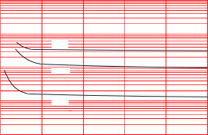
C(pF)
105

104
Ciss

Coss

102 Crss

101 VDS(V)
103
0 8 16 24 32 40

JieJie Microelectronics CO. , Ltd Version :1.0
- 3 -

JMGG020V04A
Figure 7: Normalized Breakdown Voltage vs. Junction Temperature  VBR(DSS) | Figure 8: Normalized on Resistance vs.  Junction Temperature  RDS(on)
0.9
1.3
1.0
1.2

1.1
0
20
0
Tj (℃)
- 100 -50 0 50 100 150
 | 2.5  2.0  1.5  1.0  0.5 | Tj (℃)
-100 -50 0 50 100 150 200
Figure 10: Maximum Continuous Drain Current vs. Case Temperature
Figure 9: Maximum Safe Operating Area
ID(A)
 | 200  150  120  90  60  30  0 |  | ID(A)

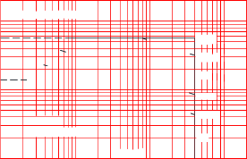
102
103
101
Limited by RDS(on)
10μs
100μs
1ms
10ms
TC=25℃
Single pulse
VDS (V)
100ms
DC
0. 1 1 10 100
 |  |  | Tc (℃)
 | 0 25 50 75 100 125 150 175
Figure.11: Maximum Effective
Transient Thermal Impedance, Junction-to-Case
ZthJ-C(℃/W)
D=0.5 D=0.2 D=0.1 D=0.05 D=0.02
D=0.01
Single
101

100

10- 1

10-2

10-3
10-5 10-4 10-3 10-2 10- 1 100 101
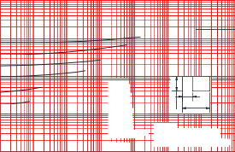
otes:N
utyfactort/tpulse1.DD=12
(s)TPeak+th*ZJ=JCC2.PTPDMT
t1 t2
PDM
10-6
JieJie Microelectronics CO. , Ltd Version :1.0
- 4 -

JMGG020V04A

Test Circuit
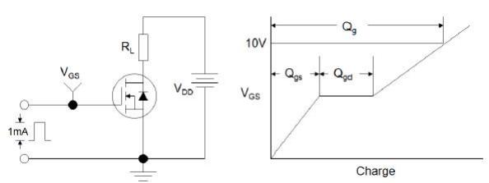
Figure1:Gate Charge Test Circuit & Waveform

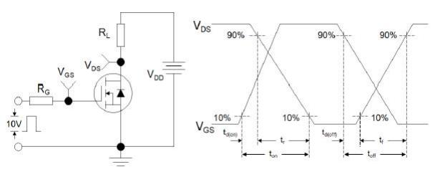
Figure 2: Resistive Switching Test Circuit & Waveforms

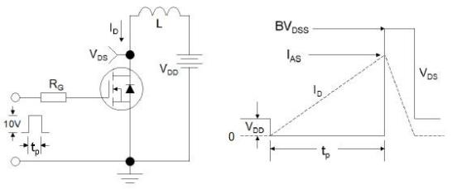
Figure 3:Unclamped Inductive Switching Test Circuit & Waveforms

JieJie Microelectronics CO. , Ltd Version :1.0
- 5 -

JMGG020V04A

Package Mechanical Data- PDFN5X6-8L
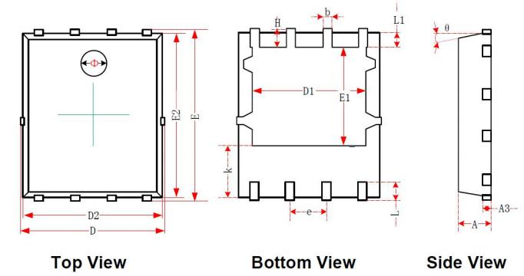

Symbol | Dimensions In Millimeters |  | Dimensions In Inches
 | Min | Max | Min | Max
A | 0.870 | 0.930 | 0.034 | 0.036
A3 | 0. 152REF |  | 0.006REF
D | 4.944 | 5.096 | 0. 195 | 0.201
E | 5.974 | 6. 126 | 0.235 | 0.241
D1 | 3.910 | 4. 110 | 0. 154 | 0. 162
E1 | 3.375 | 3.575 | 0. 133 | 0. 141
D2 | 4.870 | 4.930 | 0. 192 | 0. 194
E2 | 5.720 | 5.780 | 0.226 | 0.228
k | 1. 190 | 1.390 | 0.047 | 0.055
b | 0.350 | 0.410 | 0.014 | 0.016
e | 1.270TYP.
L | 0.559 | 0.711 | 0.022 | 0.028
L1 | 0.424 | 0.576 | 0.017 | 0.023
H | 0.574 | 0.726 | 0.023 | 0.029
θ | 10° | 12° | 10° | 12°
Φ | 1. 150 | 1.250 | 0.045 | 0.049
JieJie Microelectronics CO. , Ltd Version :1.0
- 6 -

JMGG020V04A

Information furnished in this document is believed to be accurate and reliable. However, Jiangsu JieJie Microelectronics Co.,Ltd assumes no responsibility for the consequences of use without consideration for such information nor use beyond it.
Information mentioned in this document is subject to change without notice, apart from that when an agreement is signed, Jiangsu JieJie complies with the agreement.
Products and information provided in this document have no infringement of patents. Jiangsu JieJie assumes no responsibility for any infringement of other rights of third parties which may
result from the use of such products and information.
is a registered trademark of Jiangsu JieJie Microelectronics Co.,Ltd. Copyright ©2020 Jiangsu JieJie Microelectronics Co.,Ltd. Printed All rights reserved.

JieJie Microelectronics CO. , Ltd Version :1.0
- 7 -

